Write a program for Map collaring using csp in python code

Aim :To implement the Map Coloring Problem using Constraint Satisfaction Problem (CSP).
Procedure:
- Define the map and available colors.
- Assign colors to each region.
- Ensure adjacent regions do not have the same color.
- Print the valid color assignment.

Output:
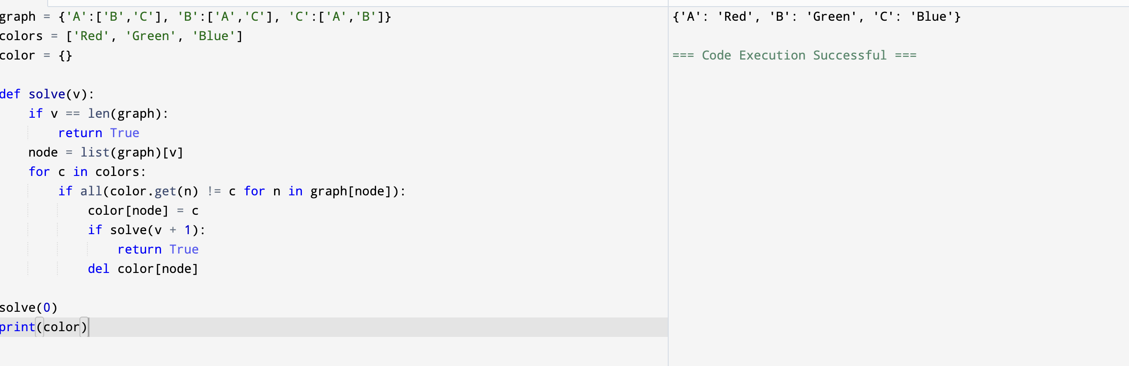

Result: Hence, Map Coloring Problem using Constraint Satisfaction Problem (CSP).
has solved

